PDA – Java

Dan Kelsey

I.T 7: Demonstrate the use of polymorphism in a program.

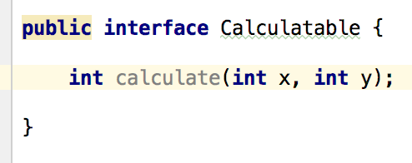

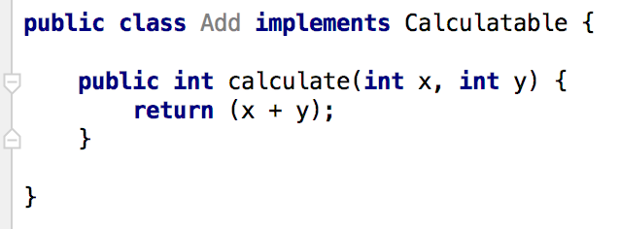

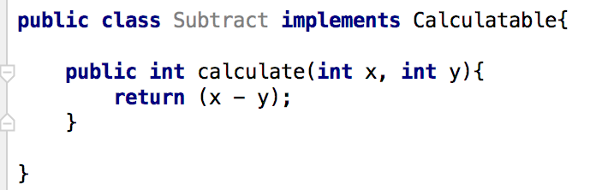

I.T 1: Take a screenshot of an example of encapsulation in a program.

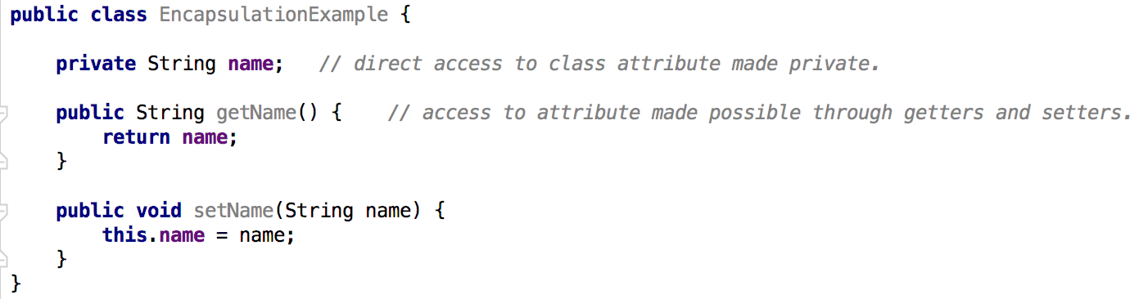

I.T. 2 Inheritance: take screenshots of

A Class:

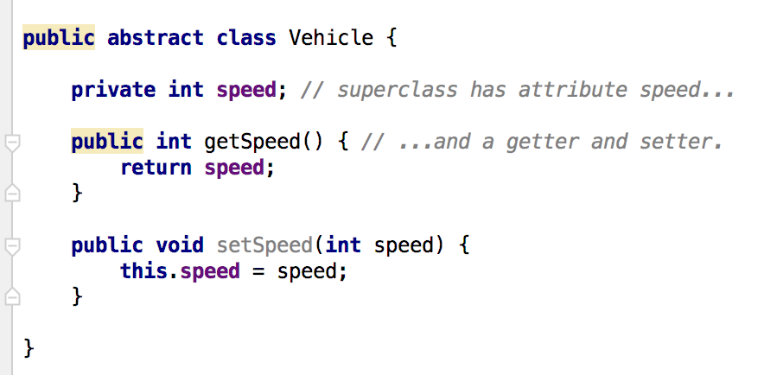

A Class that inherits from the previous class:

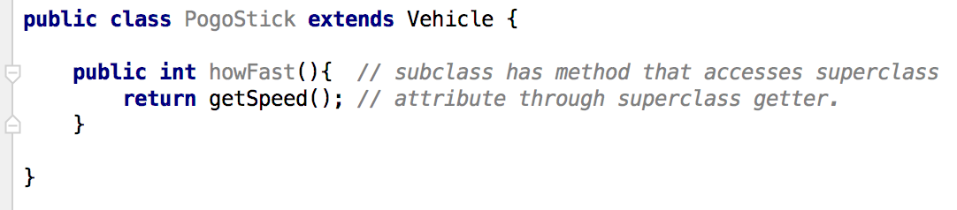

An object of the subclass’s method which uses information from the inherited class:

